Roll No.: _ _ _ _ _ _ _ _ _ _ _ _ _ _ _ _ _ _ _

Amrita Vishwa Vidyapeetham

B.Tech. First Assessment – August 2019

First Semester

Common to all Engineering Departments

19CSE100 Problem Solving and Algorithmic Thinking

**Set-4**

Time: Two hours Maximum: 40 Marks

**Course Outcomes (COs):**

|  |  |
| --- | --- |
| **CO#** | **Course Outcomes** |
| CO1 | Apply algorithmic thinking to understand, define and solve problems |
| CO2 | Understand an algorithm by tracing its computational states, identifying bugs and correcting them |
| CO3 | Apply the basic programming constructs for problem solving |
| CO4 | Design and implement algorithm(s) for a given problem |

**Answer all questions**

**Part A (20 Marks)**

1. Do you think the following algorithm (represented as a flowchart) is complete? Remember an algorithm is complete if it handles all eventualities. Explain your answer (if yes explain why it is complete and if no then why and what change(s), without violating the logic, in the algorithm make it complete). [5 Marks][CO1]

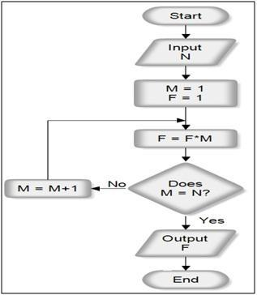

Solution: The above algorithm is not complete [1 mark]. A complete algorithm should handle all eventualities that could arise. However, in the above algorithm, cases where the value of N <= 0 has not been handled. [2 marks]. A do-while loop for reading N will ensure that negative and zero N values will be ignored, and the user will be prompted for a positive value. [2 marks]

1. The following is a flowchart intended to give the steps to be followed while seeking admission to a college. Given below are the statements in the jumbled order. Redraw the flowchart by organizing the statement in appropriate order to facilitate the flowchart to do its intended goal. [5 Marks][CO1]

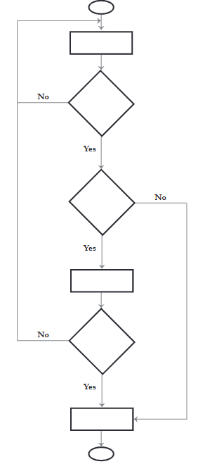

* 1. Did you pass the exam?
  2. Is there an admission test?
  3. Submit necessary documents and get the admission
  4. Search for a college
  5. Prepare for the admission test and write it
  6. Are seats available?

Solution: The right sequence is

A) Search for a college

B) Are seats available?

C) Is there an admission test?

D) Prepare for the admission test and write it

E) Did you pass the exam?

F) Submit the necessary documents and get the admission

1. The purpose of the following flow-chart is to add up the numbers in boxes 3, 4, 5, 6, 9, 10 and 11, and to put the total in box 7. In order to accomplish exactly this -- no more and no less -- what number must be in box 2? Explain your answer. [5 Marks][CO2]

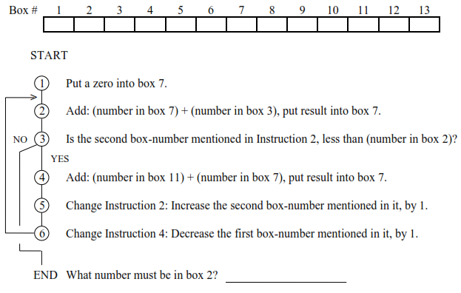

Solution:

The number in box 2 must be greater than or equal to 6. [2 Marks] The box numbers added to box 7 above the condition increases from 3 and the box numbers added to box 7 below the condition decreases from 11. The addition at the top goes till 6. At 6 if condition is true the addition after that involves box 8. So the condition should fail at box number 6. For that the value in box 2 should be either equal to or greater than 6. [3 Marks]

1. What does the following flowchart compute? Show how did you arrive at the answer. [5 Marks][CO2]

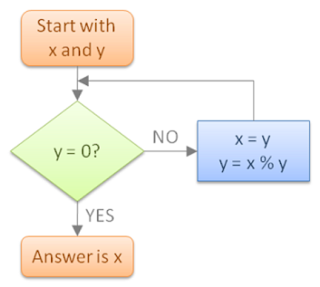

Solution: The flowchart computes GCD of x and y [2 Marks]. [3 Marks] for the steps shown to arrive at the conclusion. It includes assuming example values for X and Y and tracing the algorithm.

**Part B (20 Marks)**

1. Admission to a professional course is subject to the following conditions:

i) Marks in mathem.latics must be 60% or above

ii) Marks in physics must be 50% or above

iii) Marks in chemistry must be 40% or above

iv) Total of three subjects must be 200 or above

Or

Total in mathematics and physics must be 150 or above

Given the marks in three subjects, write a flowgorithm to compute eligibility for the professional course. [5 Marks][CO3]

1. A certain grade of steel is graded according to the following conditions:
   1. Hardness must be greater than 50
   2. Carbon content must be less than 0.7
   3. Tensile strength must be greater than 5600

The grades of steel are as follows.

* 1. Grade is 10 if all three conditions are met.
  2. Grade is 9 if conditions i and ii are met.
  3. Grade is 8 if conditions ii and iii are met.
  4. Grade is 7 if conditions i and iii are met.
  5. Grade is 6 if only one condition is met.
  6. Grade is 5 if none of the conditions are met.

Write a flowgorithm to find the grade of a given one more8 steel conditions. A sample session follows.

How many steels you want to grade: 2

Enter data: 35 0.8 5700 60 0.5 6000

Grades: 8 7

Do you want to continue (y/n): y

How many steels you want to grade: 2

Enter data: 52 0.8 5700 65 0.93

Error! Insufficient data!!

Do you want to continue (y/n): n